# **Volkswagen Demo**

## Requirements document



## Developer Edition Sandbox

<https://none36-dev-ed.lightning.force.com/lightning/setup/SetupOneHome/home>

**Username**: vwtestuser@vwdemo.com

**Password**: qwertyuiop456

## GitHub

The public repository is called “SalesDemoVW”. There are two branches: “Main” and “vwDemo”. At this moment, the two should be identical.

<https://github.com/fabeires/SalesDemoVW>

## Flow

### Lead is created and converted. Account, Contact and Opportunity are generated.

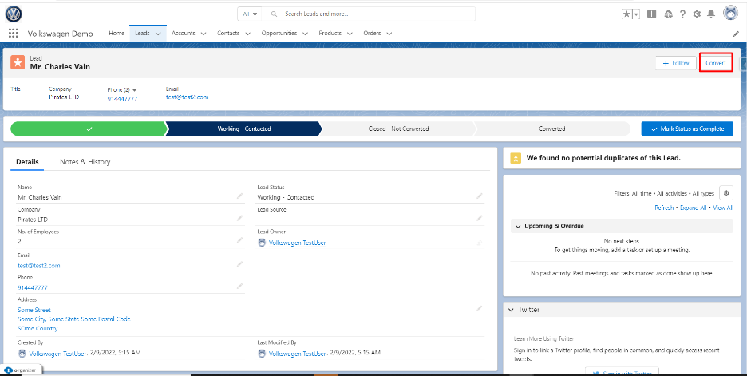

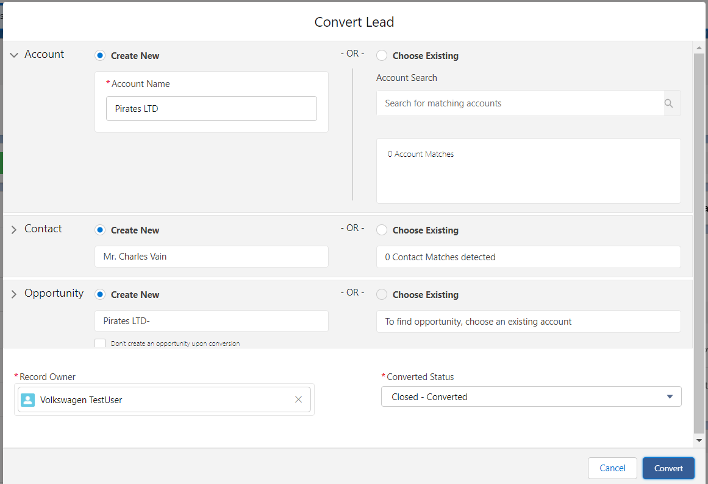

### Navigate to created Opportunity and add products to Opportunity.

Once in the Opportunity we can add or edit products after we select the price book to be used. Two price books were created, a default one and one for partners in case different prices for the same product were needed, although configuration is the same on both in this demo.

The three mentioned products in the requirements document were configured. A new record type “Vehicle” was created for these products to hold specific fields related to vehicles.

To demonstrate the subscription part since there was not much information and to easily maintain the 1 to 1 relationship, a custom field was created “Has Subscription” alongside a custom field to define the percentage “Subscription Percentage” in the Opportunity Product object. The subscription could also had been defined as a Product or even custom object could be created to make the solution more scalable but in my interpretation of the requirements, a simpler solution was applied.

Once products are added (without or without subscription and with various subscription percentages), the Unit prices are updated on each Opportunity Line Item (in a trigger function) and in the Opportunity (this last one is the standard functionality).

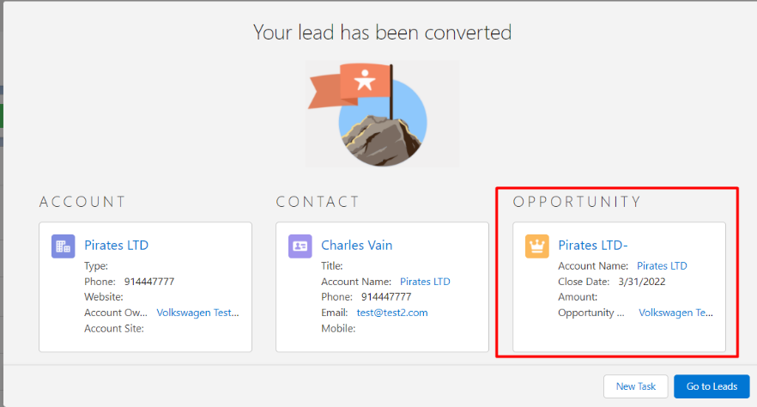

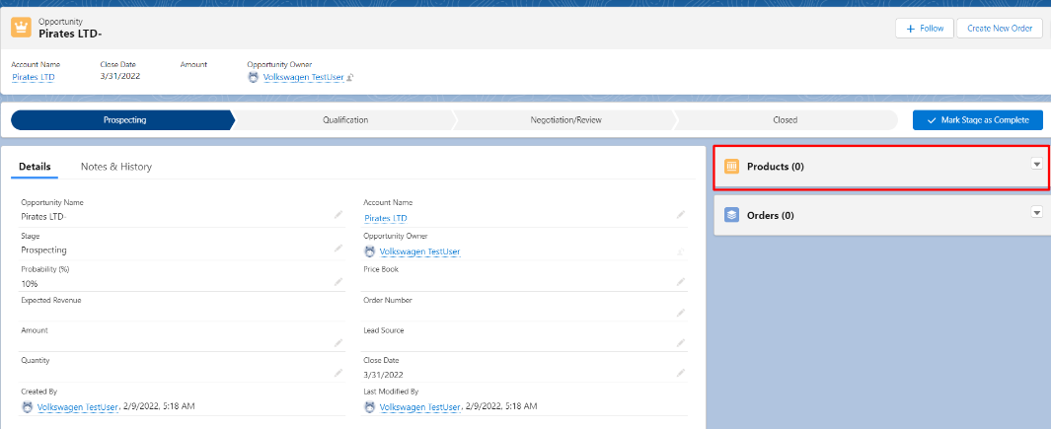

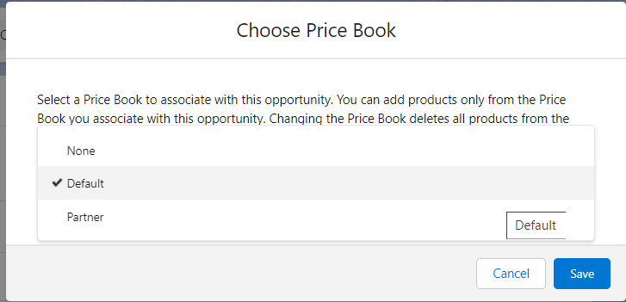

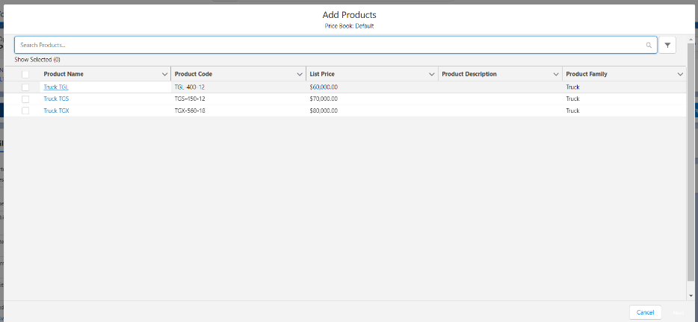

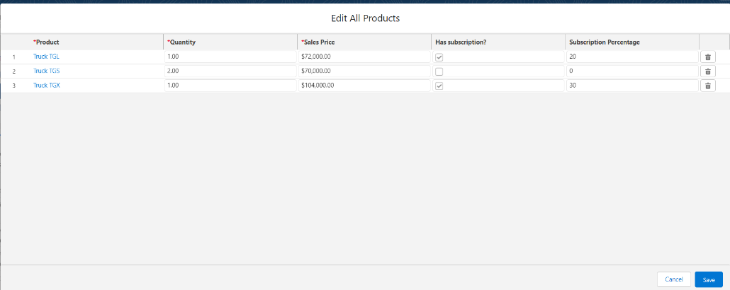

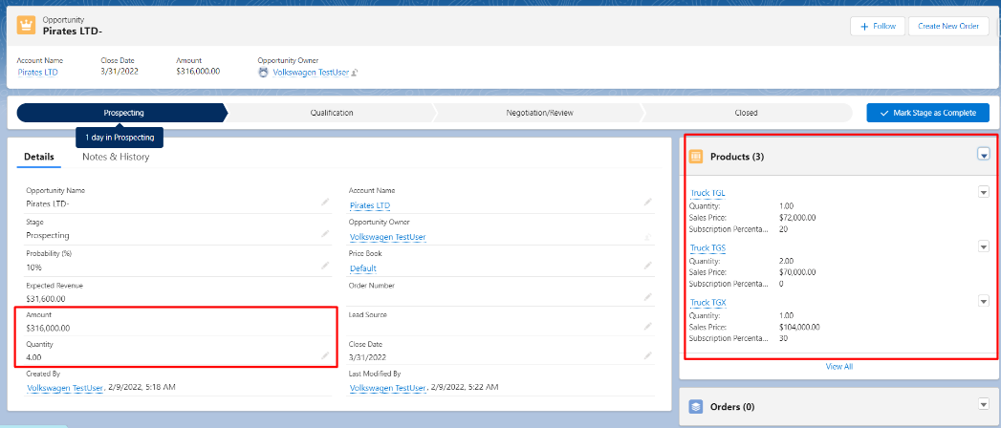

### Create new Order

Use “Create new order” quick action to generate a new order for this Opportunity once we are sure these are the products, subscriptions, percentages and quantities we want.

Once a new order is created using the quick action:

* All Opportunity Products are converted as Order Products and added to the new Order.
* The Opportunity is set as “Closed Won”.
* The Order is activated and associated with the Account record.
* All Opportunity Products are converted to Assets.
* All Assets are associated with the Account, Product and Order.
* API is called for each Asset, which is then updated.

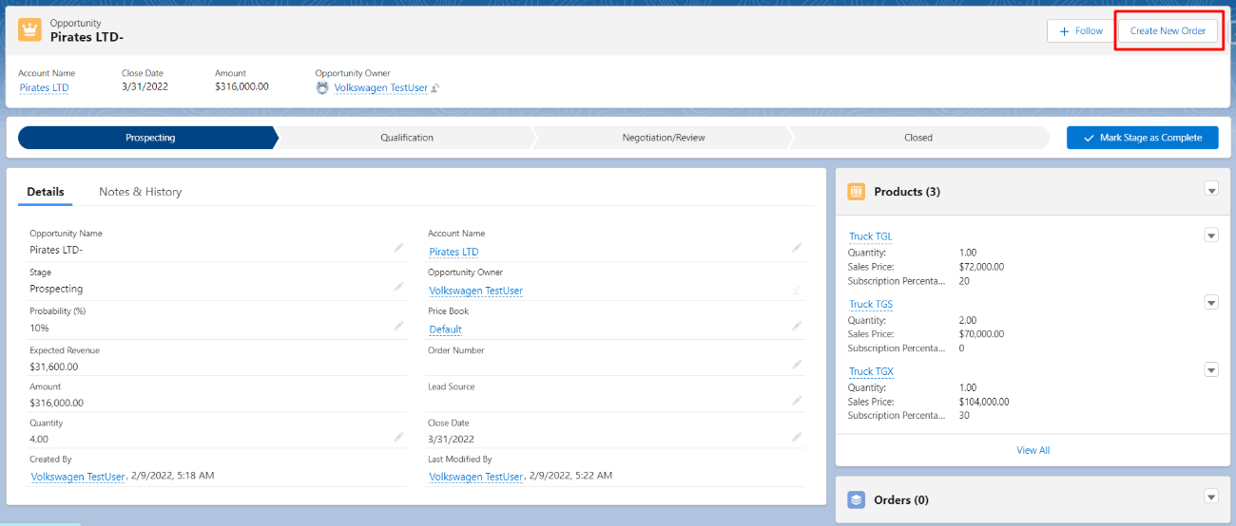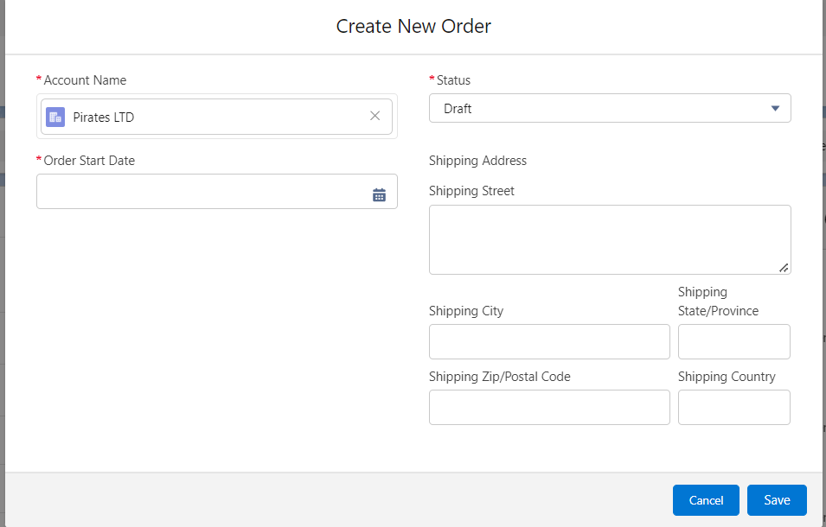

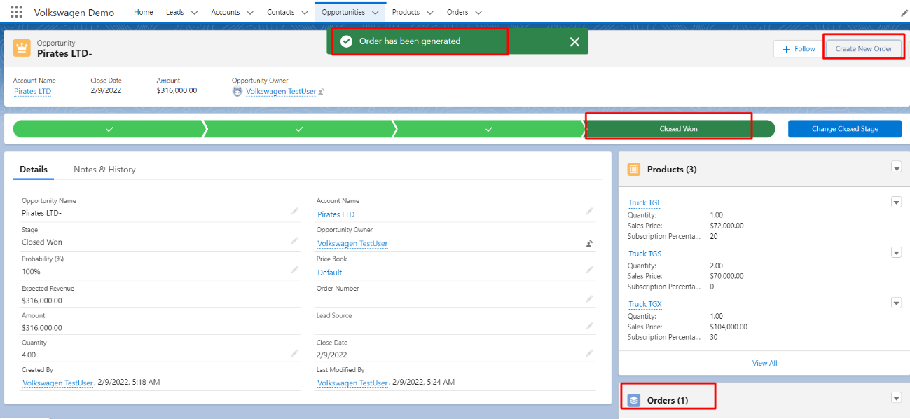

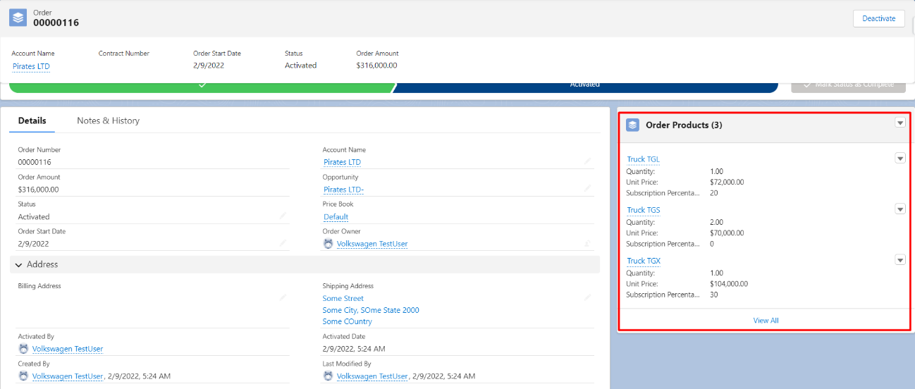

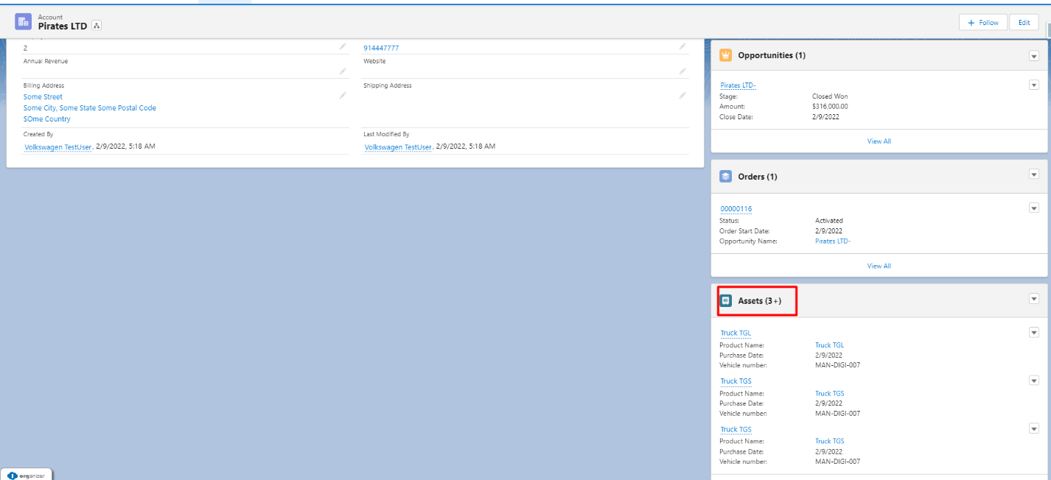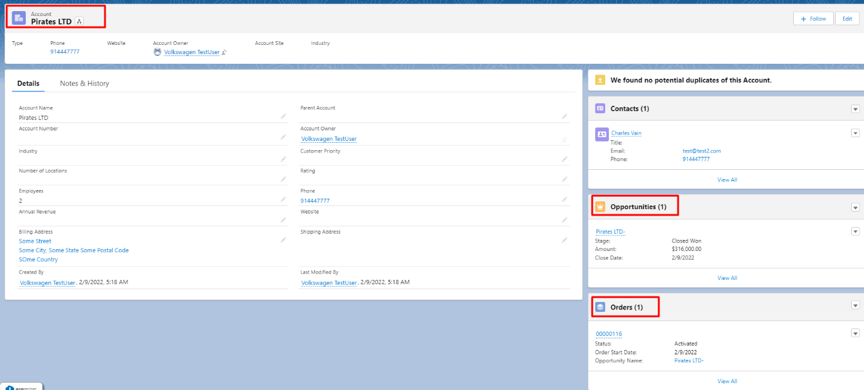

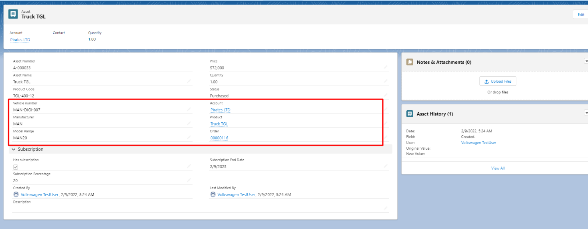

## Metadata

|  |  |
| --- | --- |
| **Metadata Name** | **Metadata Type** |
| Volkswagen Demo | App |
| AssetAPIMock | Apex class |
| [AssetBatch](javascript:srcUp(%27%2F01p7Q000008g1U5%3Fisdtp%3Dp1%27);) | Apex class |
| [AssetTriggerHandler](javascript:srcUp(%27%2F01p7Q000008g1Ps%3Fisdtp%3Dp1%27);) | Apex class |
| AssetTriggerHandlerTest | Apex class |
| [AssetUtils](javascript:srcUp(%27%2F01p7Q000008g6cM%3Fisdtp%3Dp1%27);) | Apex class |
| [AssetWrapper](javascript:srcUp(%27%2F01p7Q000008g1UK%3Fisdtp%3Dp1%27);) | Apex class |
| [OpportunityLineItemTriggerHandler](javascript:srcUp(%27%2F01p7Q000008fwcz%3Fisdtp%3Dp1%27);) | Apex class |
| [OpportunityLineItemTriggerHandlerTest](javascript:srcUp(%27%2F01p7Q000008fxq1%3Fisdtp%3Dp1%27);) | Apex class |
| [OpportunityTriggerHandler](javascript:srcUp(%27%2F01p7Q000008g1HI%3Fisdtp%3Dp1%27);) | Apex class |
| [OpportunityTriggerHandlerTest](javascript:srcUp(%27%2F01p7Q000008g1Pi%3Fisdtp%3Dp1%27);) | Apex class |
| [OrderTriggerHandler](javascript:srcUp(%27%2F01p7Q000008g5Uq%3Fisdtp%3Dp1%27);) | Apex class |
| [OrderTriggerHandlerTest](javascript:srcUp(%27%2F01p7Q000008g5V5%3Fisdtp%3Dp1%27);) | Apex class |
| [WebserviceUtils](javascript:srcUp(%27%2F01p7Q000008g2hc%3Fisdtp%3Dp1%27);) | Apex class |
| [AssetTrigger](javascript:srcUp(%27%2F01q7Q0000000OYl%3Fisdtp%3Dp1%27);) | Apex trigger |
| [OpportunityLineItemTrigger](javascript:srcUp(%27%2F01q7Q0000000OXT%3Fisdtp%3Dp1%27);) | Apex trigger |
| [OpportunityTrigger](javascript:srcUp(%27%2F01q7Q0000000OYW%3Fisdtp%3Dp1%27);) | Apex trigger |
| [OrderTrigger](javascript:srcUp(%27%2F01q7Q0000000Ou7%3Fisdtp%3Dp1%27);) | Apex trigger |
| Vehicle | Product Record Type |
| AllowSubscription | Validation Rule |
| Demand_Subscription_percentage | Validation Rule |
| ActivatedOrderCanNotChange | Validation Rule |
| OrderProductNotEditable | Validation Rule |
| AssetAPI | Remote Site Setting |
| Create New Order | Quick Action |
| AddProductsToOpp | Custom Label |
| AlreadyAssociatedOrder | Custom Label |
| AssetAPIMockData | Custom Label |
| AssetPurchased | Custom Label |
| ClientIdHeader | Custom Label |
| ClientSecretHeader | Custom Label |
| ContentTypeHeader | Custom Label |
| ContentTypeJson | Custom Label |
| CorrelationIdHeader | Custom Label |
| OpportunityClosedWon | Custom Label |
| OpportunityOpen | Custom Label |
| OrderActivated | Custom Label |
| OrderDraft | Custom Label |
| PreventOpportunityClosedWonChange | Custom Label |
| AssetEnrichmentParameters__c | Custom Setting |
| Opportunity by Stage | Report |
| Won Opportunities above 100 K | Report |
| Leads this month | Report |
| VW Demo Home Page | Dashboard |
| Has_subscription__c | Opportunity Product Custom Field |
| Subscription_Percentage__c | Opportunity Product Custom Field |
| Has_subscription__c | Order Product Custom Field |
| Subscription_Percentage__c | Order Product Custom Field |
| Asset_Number__c | Asset Custom Field |
| Has_subscription__c | Asset Custom Field |
| Subscription_Percentage__c | Asset Custom Field |
| Subscription_End_Date__c | Asset Custom Field |
| Vehicle_number__c | Asset Custom Field |
| Manufacturer__c | Asset Custom Field |
| Model_Range__c | Asset Custom Field |